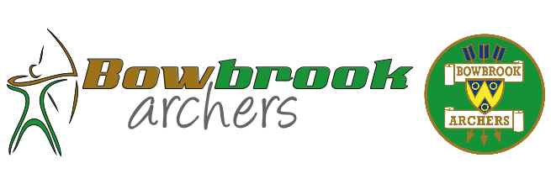
2021 Beginner’s Course
Application Form.

(Please complete one form for each person)

Surname: ............................................ Given name: ……………………… Age:....................
(if under 18)

Address: .............................................................................................. Postcode: ...............

Contact No: ......................................... Email: .......................................................................

Approximate height: …………………. Are you Left / Right Handed?: …………..

Preferred Course(s) (starting dates): .........................................................................

Course(s) NOT suitable (starting dates): …………………………………………

Please give details of any medical conditions or other information the club needs to be aware of to help you get the most from Archery. {If you have any special requirements, and would like to discuss these, in confidence, please state and our Beginners Co-ordinator will contact you directly}:

. . . . . . .

I agree to abide by the Archery GB Rules of Shooting, which will be explained to me. I agree that Bowbrook Archers Ltd or any paid-up member of Bowbrook Archers Ltd is not liable beyond the scope of the Archery GB public liability insurance scheme for any accident or injury that I may incur whilst undertaking the sport of archery as a registered Beginner with Bowbrook Archers.

Bowbrook Archers reserve the right to refuse instruction to any person who is deemed to present a danger to themselves and/or others.

Juniors under 16 must be supervised at all times by a responsible adult. Bowbrook Archers will not accept, or instruct, any unsupervised junior. Parents should please note that Coaching may involve an element of physical contact.

Details of Fee payment methods will be included with the email confirming you have been allocated a place. We will contact you as soon as is possible.

Signature Responsible Adult: ................................................................. Date: ...............
if under 18

Thankyou for your interest in our Beginners Course. We look forward to meeting you soon.

Bowbrook Archers.

Please email your completed form to our Beginners Co-ordinator, at timswane826@btinternet.com

Please note that the personal data you provide on this form will only be used to ensure you get the best from a Bowbrook Archers Beginner’s Course. The information will only be used to ensure the safe and appropriate running of Courses. Once the Course has concluded, all said data will be destroyed within six months. At no time will your information be provided to any other party, for any other reason.

